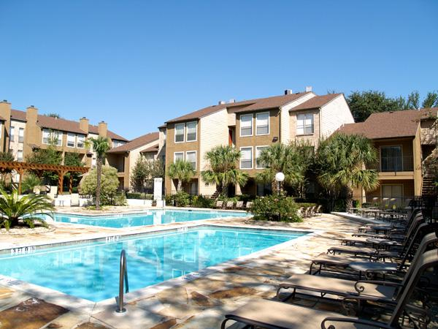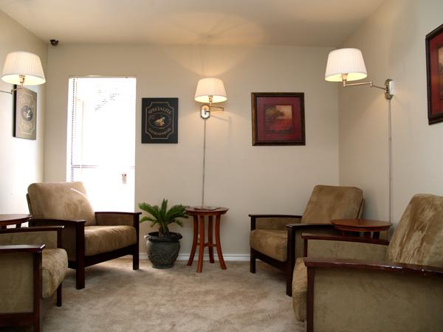

Apartment 1-Bedroom
$680 per month

Interior Amenities
Pets Allowed
Dogs Allowed
Cats Allowed
Central Air/Heating
Kitchen Appliances
Tile Floors
Fireplace
Fitness Center
Walk in Closets
Cinema Room
Patio
Ceiling Fans
Berber Carpet
Microwave
Exterior Amenities
Jacuzzi/Hot Tub
Pool
Parking
Gated Community
Balcony/Deck
Business Center
Volleyball Court
Picnic Area
Laundry Facility

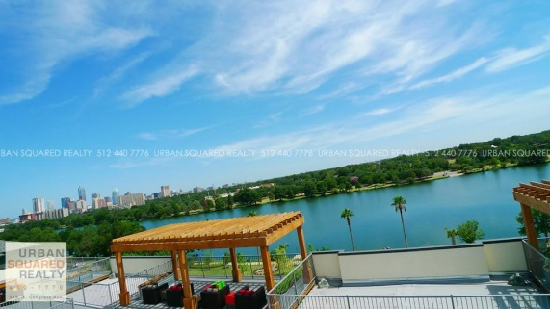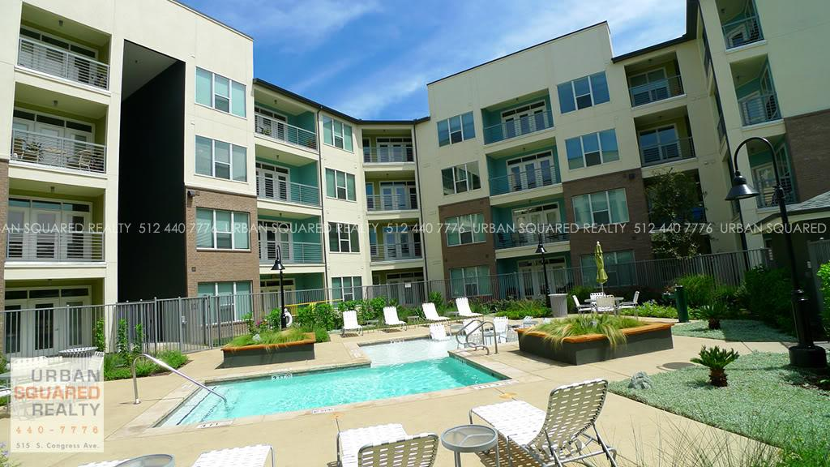
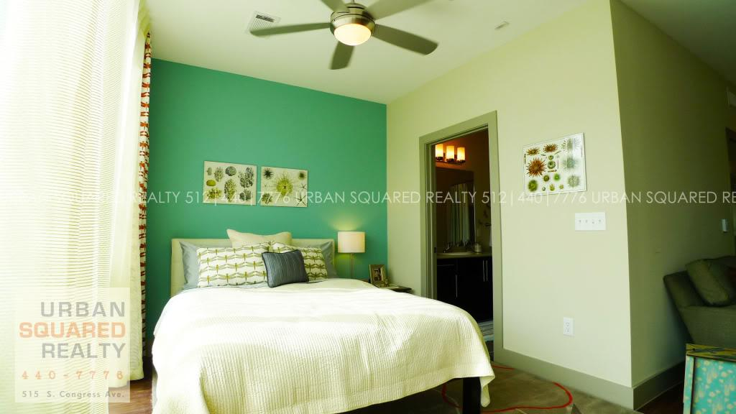

Apartment - 1 bedroom
$1225 a month

Call Joan to view
512-514-5889
Urban2Realty
- cats are OK - purrr
- dogs are OK - wooof
- Location: Downtown / 512-514-5889 / Central

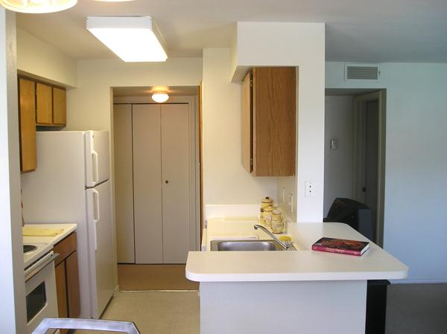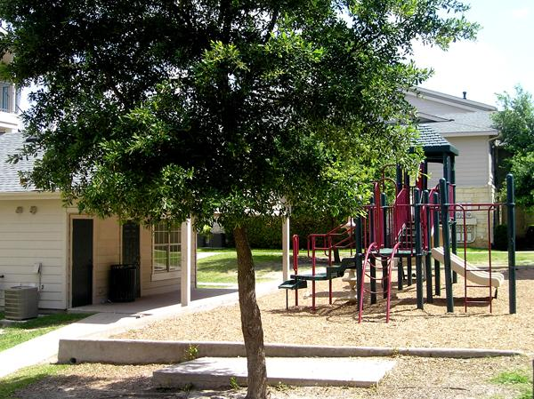

Apartment 2 Bedroom
$789 per month

Interior Amenities  Pets Allowed  Dogs Allowed  Cats Allowed  Central Air/Heating  Kitchen Appliances  Master Bedroom  Patio  Ceiling Fans  Laundry Rooms  Microwave  Outside storage | Exterior Amenities  Pool  Parking  Balcony/Deck  Picnic Area  Roommate Floorplans  Laundry Facility  Fitness Center

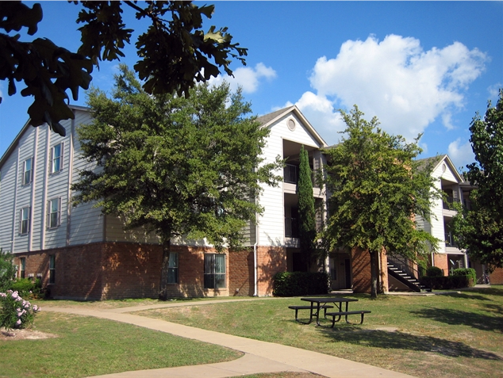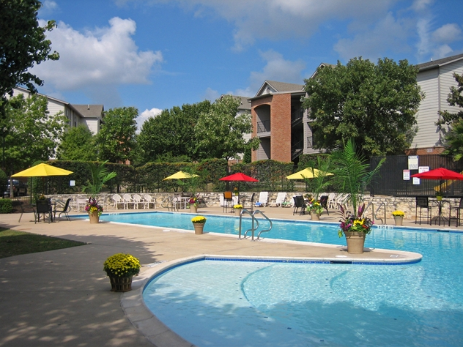

Apartment for rent - 4 bedroom
$1025
Pflugerville

Interior Amenities  Pets Allowed  Dogs Allowed  Cats Allowed  Central Air/Heating  Washer/Dryer  Kitchen Appliances  Walk in Closets  Patio  Ceiling Fans  Berber Carpet  Vaulted Ceilings  Outside storage | Exterior Amenities  Pool  Parking  Garage  Gated Community  Volleyball Court  Basketball Goal/Court  Picnic Area  Roommate Floorplans  Laundry Facility
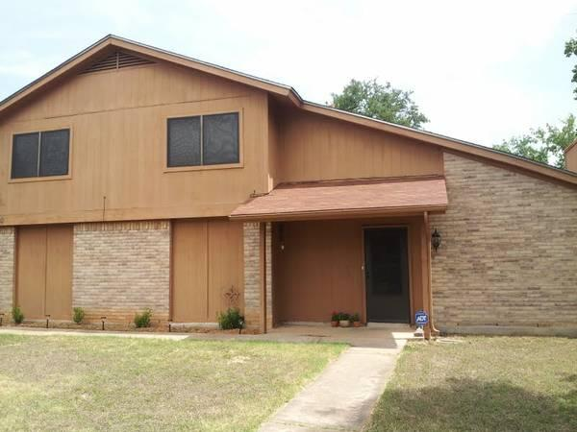

House for Rent
3 bedroom $1350 a month

Lovely south Austin home for rent. Available now. Small dog allowed with pet deposit. Located off east William Cannon near shopping, restaurants, etc. Only 8 miles from downtown. In cul-de-sac with large, fenced backyard, attached garage. Refrigerator, dishwasher, washer/dryer, stove, built-in microwave on site.

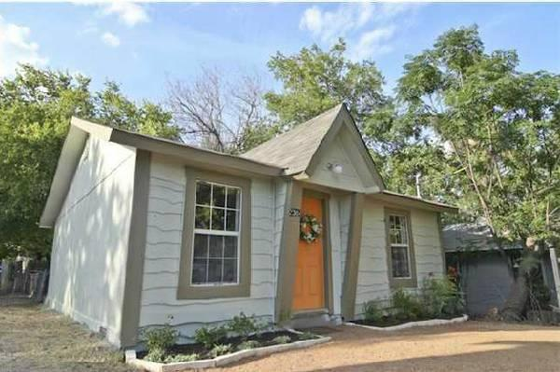

House for rent 2 bedroom
$1195 per month

Adorable East Side Remodel with a Perfect Location and an eye catching Yellow Door
- Walk to the Wet Whistle, Walk Downtown, Walk to UT, LOCATION
- Just Remodeled, New Flooring, Hardwood in all living area's except bedroom
- Cosigners and Pets accepted!

